Episode 409: Uniform electric fields

So far we have mainly concentrated on the non-uniform fields around point or spherical charges. We will now discuss the physics of the uniform electric field, such as that between 2 parallel charged plates. The basic definitions of field strength and potential lead to different results than those for the non-uniform field.
Lesson Summary
- Discussion: Uniform electric fields (5 minutes)
- Demonstration: Potential and field strength in a uniform field (25 minutes)
- Discussion: Accelerating charges through a potential difference (10 minutes)
- Student questions: Uniform electric fields (10 minutes)
- Student questions: Millikan’s oil drop experiment (10 minutes)
- Discussion: Comparison of gravitational and electric fields (10 minutes)

Discussion: Uniform electric fields
What do we mean by a uniform field? (One that does not vary from place to place. In terms of the field lines, this means that they are parallel and evenly spaced. Also as field strength = − (potential gradient), the equipotentials should also be evenly spaced.)
Where have we seen such as field? (The field between two parallel charged plates.)
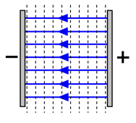
How will a charge move in such a field? The force is given by
F = E × Q
Since E is constant, the force will be constant and therefore, by
F = m × a
the acceleration will also be constant and directed along the field lines for a positive charge and opposite to the field lines for a negative charge. (Note: A constant acceleration produces a parabolic path for the charge if it has any component of motion across the field lines, just as with projectiles in the Earth’s constant gravitational field near its surface).

Demonstration: Potential and field strength in a uniform field
A flame probe can be used to test the potential in the uniform field. Also, plotting a graph of potential against distance between the plates gives us the field strength because
E = – (potential gradient)
This demo will confirm the fact that the equipotentials are evenly spaced and parallel to the plates, giving a uniform electric field perpendicular to the plates.
Episode 409-1: Potential and field strength in a uniform electric field (Word, 65 KB) - see end of document

Episode 409-2: Flame probe construction (Word, 237 KB) - see end of document
-
Now, since E = – (potential gradient), but the potential gradient is uniform as we have seen, the electric field strength will simply be given (in magnitude) by:
E = Vc
where:
- V is the potential difference between plates (in volts)
- d is the distance between plates (in metres)
The direction of the field is obviously from the positive to the negative plate.

Discussion: Accelerating charges through a potential difference
What happens when a charge is accelerated through a potential difference? If there is a potential difference between two points, there must be a field between them since E = – (potential gradient). Thus a charge that moves between the two points under the action of the field has work done on it by the field (as work = force × distance and a force is provided by the field). For a potential difference of V between two points, the work done by the field on a charge Q as it moves between those points is given by: W = V × Q
where W is work done in joules, J.
(Careful here – so far we have used V as the symbol for potential, and V as the unit for potential, volts. Now we are using it for a potential difference . If this is likely to be a source of confusion, you may wish to adopt an expression like
W = Q × Δ V , with Δ meaning change in).
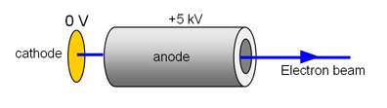
We can use this expression to calculate the energy gain as a particle moves with a field or the energy loss as it moves against it.
(Note that it is also used to define the electron-volt, a unit of energy equal to that gained by an electron as it falls through a pd of 1 V,
i.e. W = 1 eV
W = 1.6 × 10⁻¹⁹ C × 1 V
W = 1.6 × 10⁻¹⁹ J).
In fact this expression is really nothing more than the statement that potential is the energy per unit charge. In this case, V = W/Q is simply stating that the change in energy (or work done) per unit charge is equal to the change in potential (or potential difference), V .

Student questions: Uniform electric fields
Episode 409-3: Uniform electric fields (Word, 43 KB) - see end of document

Worked examples: Millikan’s oil drop experiment
Episode 409-4: Millikan’s oil drop experiment (Word, 42 KB) - see end of document

Discussion: Comparison of gravitational and electric fields
We finish this topic by discussing the parallels between gravitational and electric fields. You could ask your students to show the parallels in their own way – a useful summarising activity. Here are the main points that they should come up with:
We have seen the following similarities:
- Both fields follow an inverse square law for both force and therefore field strength
- For both types of field, potential and energy stored in the field are inversely proportional to distance
- We define the zero of potential to be at infinity
- For attractions (and therefore always for gravitational fields) energies are always negative. As work always has to be done on the object (charge or mass) to keep it at that point in the field.
- The major difference is that repulsions occur in electrostatic fields between charges of the same sign, whereas as far as we know, gravity is always attractive
The similarity of the fields may be brought home further by comparing the forms of the equations.
Episode 409-1: Potential and field strength in a uniform electric field

A flame provides a small number of ions, allowing a conductor to acquire the same potential as the place where you put it. So the flame probe provides a convenient way of measuring the potential at a point in an electric field. Here you can look at the variation in potential difference within a uniform field, between two parallel metal plates.

You will need:
✓ demonstration digital multimeter
✓ EHT power supply 0–5 kV dc
✓ pair of large aluminium plates
✓ clip component holder
✓ 10 MΩ resistor (in addition to that in the EHT supply)
✓ 4 mm leads
✓ two slotted bases
✓ metre rule
✓ flame probe
✓ retort stand, boss and clamp
✓ gas supply
✓ calibration coil (optional)

! | Wire carefully, EHT voltages  School EHT supplies have an output limited to 5 mA or less which makes them safe. In this experiment, very low currents are sufficient so the extra resistor (e.g. 50 MΏ can be included in the circuit is it is built into the supply.  Note the high voltage on the capacitor plate, the naked flame on the flame probe and the sharp point on the hypodermic needle.

TAP 409-2: Flame probe construction

Checking and calibrating the flame probe

Before you can measure how the potential difference changes as you move between the plates, check the action of the flame probe.
Everywhere inside the copper coil is at the same potential above 0 V. You can see that the flame probe measures the potential difference above ground in this space by altering the output pd on the EHT power supply.

flame probe
E.H.T
+
_
Internal protective resistor
(10 or 50 MΩ)
10 MΩ
Internal resistor 1 MΩ
V

You can use this arrangement to calibrate the flame probe, matching the numbers on the EHT power supply to the numbers appearing on the multimeter. Note that the multimeter is only measuring a fraction of the pd, as it forms part of a potential divider.

Measuring potential differences
You are now in a position to measure how the potential difference changes at different locations within a uniform electric field.

10 MΩ
E.H.T
+
_
V
metre rule

Explore the region between the plates by taking readings of potential at various distances from the plates (between the plates). At a given distance, you can take a few readings of potential by moving the flame probe parallel to the plates.

You should find that:

1) The graph of potential difference against distance from the earthed plate is a straight line through the origin.

2) The potential gradient (= – the electric field) is constant.

3) The equipotentials are parallel to the plates, i.e. they are at right angles to the electric field.

Practical advice
The probe is a device that uses a small flame as source of ions, to allow a fine conductor to reach a steady pd, determined by the potential of the surrounding electric field at that point.
The probe is made from a fine tube (e.g. a hypodermic needle) through which there is a slow flow of gas to maintain a flame. An insulated wire provides the route from the point of the flame to a voltmeter. A Hoffman clip on the gas supply tubing enables the pressure to be adjusted until a small flame (2 to 3 mm long) is obtained at the tip. (Hint: Start with the clip open so that the gas flows relatively freely and be patient before trying to light the gas; it takes some time to clear the air out of the tubing. Before lighting the gas, reduce the flow, as too high a pressure blows the flame away.)
Further details of the construction of the flame probe are given in Teacher and technician notes.
The two aluminium plates have to be mounted vertically about 20 cm apart, on an insulator (most bench tops are fine, but on a wooden bench it is best to insulate the non-earthed plate by placing a polystyrene sheet between the plate and bench). One plate is connected to the positive terminal of the EHT power supply and the other to the earthed negative terminal. When the connections have been made, turn the supply on and touch each plate with the (unlit) needle of the flame probe to check that the multimeter indicates the expected potential differences.
Place the flame probe half-way between the plates somewhere near a line joining the centre of the two plates. You may also find it clearest to have the hypodermic needle pointing straight up.
The voltmeter should read about half the potential of the positive plate. If you move the flame probe parallel to the plates, you will notice that the voltmeter reading does not change. You are following an equipotential. Other equipotentials can be found at different distances from the plates. In all positions, you should find that moving parallel to the metal plates does not alter the potential.
Return the flame probe to a position close to the centre of the negative plate and fix a ruler to the bench so that you can measure the distance of the probe along a line joining the plates. By taking measurements of the potential at points along this line, you will be able to plot a graph of the potential against distance from the earthed plate.

! | Wire carefully, EHT voltages  School EHT supplies have an output limited to 5 mA or less which makes them safe. In this experiment, very low currents are sufficient so the extra resistor (e.g. 50 MΏ can be included in the circuit is it is built into the supply.  Note the high voltage on the capacitor plate, the naked flame on the flame probe and the sharp point on the hypodermic needle.

Technician note
Details of the flame probe construction are given in

TAP 409-2: Flame probe construction

External reference
This activity is taken from Advancing Physics chapter 16, 30D
Episode 409-2: Flame probe construction

What these are for
These devices enable the measurement of a pd in space, by providing a supply of ions to a conductor, one end of which is attached to a voltmeter. The other end of the voltmeter is usually earthed.
One method of construction is to use large diameter hypodermic needles, which can act so as to supply both the gas, which is then lit to provide ions, and an electrical path to the voltmeter. However large diameter needles are hard to come by, so you can use very narrow diameter tubing, available from modelling shops. You may also see some pedagogic advantages to keeping the ion supply and the electrical contact separate, to help in the explanation of the workings of a flame probe.

Making a single probe
The device needs to allow a variable supply of gas to a metal tube about 1 mm in diameter. Rubber or PVC tubing is used to connect the tube to the gas supply. An insulated wire is used to provide the electrical path to a voltmeter and the whole is taped to a long insulated rod (e.g. Perspex, polythene or wood) that is held in a clamp (wooden if possible). A Hoffman clip on the gas supply tubing enables the pressure to be adjusted until a small flame (2 to 3 mm) is obtained at the tip.
(Hint: Start with the clip open so that the gas flows relatively freely and be patient before trying to light the gas; it takes some time to clear the air out of the tubing. Before lighting the gas, reduce the flow, as too high a pressure blows the flame away.)
Both the gas tubing and insulated wire to the voltmeter need to be long (about 2 m) so that the probe can be moved easily without disturbing the flame.
One design uses a 25 gauge hypodermic:

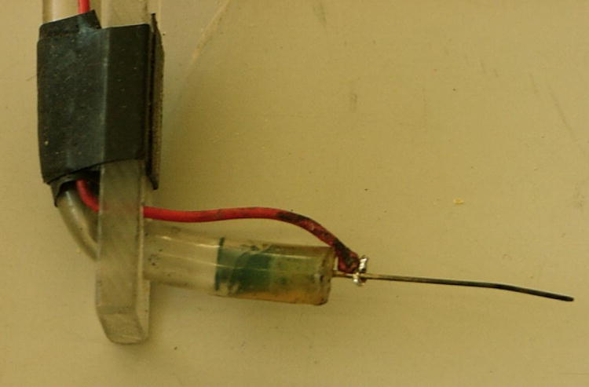

A second design uses narrow diameter tube (1 mm internal diameter aluminium tube works well, and seems to be readily available from modelling shops). Reducing the diameter of the tubing can be achieved from a combination of heat shrink tubing and extruded soda glass tubing, as shown in the detail below.

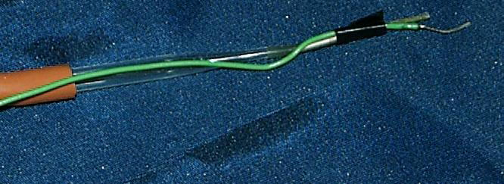

Making a dual probe
A dual probe consists of two single probes, able to be rotated, and separated by a fixed, but variable distance:

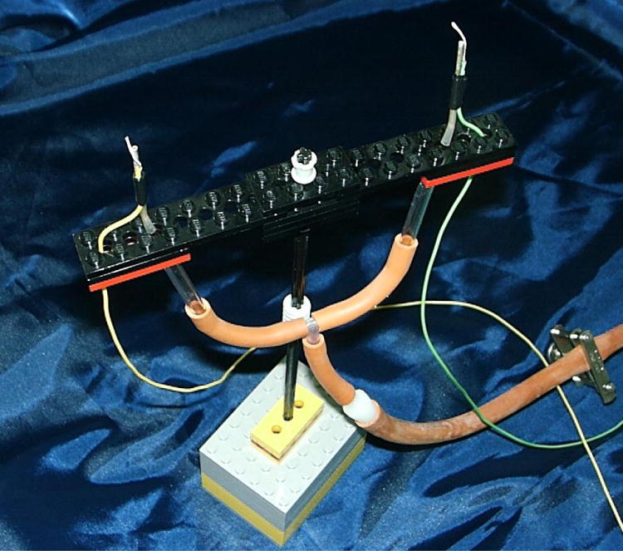

Making the calibrating coil
A single coil of thick bare copper wire, mounted in a 4 mm socket will suffice. The inside diameter and length of the coil should be sufficient to enclose a small flame and at least 1/3 of the metal probe forming the end of the flame probe.

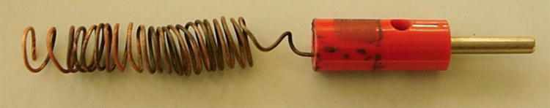

Important features
• That there be a variable supply of gas, to produce as small a flame as possible.
• That this gas supply is led out to a narrow tube, to further control the flame.
• That a conductor, connected to a long lead, be in electrical contact with this flame.
• That the whole can be rigidly mounted in such a way that its position in a field is easily changed.

! | Wire carefully, EHT voltages  School EHT supplies have an output limited to 5 mA or less which makes them safe. In this experiment, very low currents are sufficient so the extra resistor (e.g. 50 MΏ can be included in the circuit is it is built into the supply.  Note the high voltage on the capacitor plate, the naked flame on the flame probe and the sharp point on the hypodermic needle.

External reference
This activity is taken from Advancing Physics teacher and technician notes A2 disc.

Episode 409-3: Uniform electric fields

Data required:
charge of electron = 1.6 × 10⁻¹⁹ C
mass of electron = 9.11 × 10⁻³¹ kg.

1) Here are two closely spaced metal plates connected to a 500 V supply.

Draw solid lines to represent the electric field both between the plates and just outside the plates. Add arrows to indicate the direction of the field.

2) Add, and label, dotted lines to the diagram of question 1, to represent lines of equipotential at 100 V intervals.

3) In an experiment to measure the charge on an oil drop, the potential difference between two parallel metal plates 5 mm apart was 300 V.
a) Calculate the electric field strength between the plates.

b) Calculate the electrical force on a small oil drop carrying a charge of 3.2 × 10⁻¹⁸ C.

4) Calculate the energy, in joules, gained by an electron accelerated through a potential difference of 50 kV in an X-ray machine.

5) Calculate the speed of an electron with a kinetic energy of 100 eV.

Hints
3. Remember to convert millimetres to metres.
4. Use the magnitude of the electronic charge. The negative sign is best ignored in this calculation.
5. Remember to convert the electron volts into joules.

Practical advice
These questions are intended to be easy, to reinforce understanding and to build confidence

Answers and worked solutions

2) Green lines above (without arrows).

3) a) E = V/d = 300 / 0.005 = 6 x 10⁴ V m⁻¹.

b) F = EQ = 6 x 10⁴ x 3.2 x 10⁻¹⁸ = 1.92 x 10⁻¹³ N

4) W = QV = 1.6 x 10⁻¹⁹ x 50,000 = 8 x 10⁻¹⁵ J

5) The energy gained will have a positive value. Both the charge and the potential difference are negative:

$$\begin{aligned}\text{100} \text{eV} = \text{100}×(1\text{.}6×{\text{10}}^{−\text{19}} J) \\ 1\text{.}6×{\text{10}}^{−\text{17}} J \\ \frac{1}{2}{\text{mv}}^{2} = 1\text{.}6×{\text{10}}^{−\text{17}} J\end{aligned}$$
so
$$\begin{aligned}v = {\left\{[2×(1\text{.}6×{\text{10}}^{−\text{17}} J)]/(9\text{.}1×{\text{10}}^{−\text{31}} \text{kg})\right\}}^{1/2} \\ 5\text{.}9×{\text{10}}^{6} m s^{−1}\text{.}\end{aligned}$$

External reference
This activity is taken from Advancing Physics chapter 16, 10W
Episode 409- 4: Millikan’s oil drop experiment

Data required
charge on electron = 1.6 × 10⁻¹⁹ C
gravitational field strength = 9.8 N kg^{–1}

These questions are about an experiment designed to measure the charge on an electron. In this experiment, ‘Millikan’s Oil Drop Experiment’, two parallel metal plates, 3.2 × 10⁻² m apart, are connected to a 600 V power supply:

1) Draw four arrowed lines on the diagram to show the electric field between the plates, well away from the edges of the plates.

2) Add dotted lines to the diagram to represent the 200 V and 400 V equipotentials between the plates. Indicate which is which.

3) Calculate the electric field strength between the two plates.

4) The electric field between the plates just supports the weight of an oil drop of mass 1.8 × 10⁻¹⁵ kg, which has acquired a charge due to a few excess electrons. Calculate the charge on the oil drop.

5) What is the most likely number of excess electrons acquired by the oil drop?

Practical advice
Questions 1–5 deal with the simple principles involved in Millikan’s experiment

Answers and worked solutions

1) Orange lines above, with arrows

2) Green lines above, without arrows

3) E = V/d = 600 / 3.2 x 10⁻² = 18,750 V m⁻¹ = 1.9 x 10⁴ V m⁻¹ (2sf)

4) electric force upward = weight downward
EQ = mg
Q = mg/E = 1.8 x 10⁻¹⁵ x 9.81 / 1.9 x 10⁴ = 9.4 x 10⁻¹⁹ C

5) 9.4 x 10⁻¹⁹ / 1.6 x 10⁻¹⁹ = 5.9
Therefore, most likely number of extra electrons = 6.

External references
This activity is taken from Advancing Physics chapter 16, 60S

